**LAVI-CABS**

**PROJECT REPORT**

Submitted for the course: Internet and Web Programming (CSE 3002)

By

**(Name of students with reg. number)**

|  |  |
| --- | --- |
| **VISHAL BHASKAR** | **15BCE0048** |

**Name of faculty: Prof. Lydia Jane G**

**(SCOPE)**

**Slot:E1**



**NOVEMBER,2017**

**ABSTRACT**

In this project we made a website for Cab allocation named as Lavi Cans in which there are 3 modules. The modules are for Admin, driver and customer. The admin can manipulate the cabs. Then, as a customer one can check the availability of a vehicle and thus book it. As a server he can give information to database when he is booked (and the place to which he is going) or when he reaches back after finishing a task. The driver is responsible to feed the data when he completes a task. Therefore, we would be able to solve the problem of non availability and improper management of car. We tried to do something new, to show a good alternative.

Contribution of Vishal Bhaskar: Homepage, Grab now(booking a cab that includes calculating distances between places and thus calculating the money), travel log in which admin can see all the travel done, Driver portal.

1. **Introduction:**
   1. **Objective and goal of project:**

This project aims at presenting a new alternative for cab allocation system. In this project we use MySQL to store the data and to change it as required. For the front end we are using HTML and CSS. The rest of the functionalities like connection between the front end and database and others are provided by JavaScript and PHP. There are 3 user interfaces present here. One for the admin who can manipulate the data of the system and view it. Another for the driver which can provide the information after coming back. And the last one is for the user to book the cab of desired type between the two destinations.

* 1. **The base triads.**

Hypertext Markup Language (HTML) is the standard markup language for creating web pages and web applications. With Cascading Style Sheets (CSS) and JavaScript it forms a triad of cornerstone technologies for the World Wide Web. Web browsers receive HTML documents from a web server or from local storage and render them into multimedia web pages. HTML describes the structure of a web page semantically and originally included cues for the appearance of the document.

* 1. **PHP**

PHP is a server-side scripting language designed primarily for web development but also used as a general-purpose programming language. PHP code may be embedded into HTML or HTML5 markup, or it can be used in combination with various web template systems, web content management systems and web frameworks. PHP code is usually processed by a PHP interpreter implemented as a module in the web server or as a Common Gateway Interface (CGI) executable.

1. **The User interfaces**

**2.1 The admin interface**

Here one can manipulate the data in the allocation system. It is thus password protected for the safety purposes. The admin can introduce a new cab type or just introduce a new cab in existing cab type. He can delete the whole cab type or a particular cab, like when the cab is out of service, he can delete it. The admin can also view all the cab type present and their status. He can also view all the cab allocation and travel logs which means which cab was booked for where.

**2.2 The driver interface**

This interface is for the drivers of the cabs. Here the driver is asked for his cab number, unique id, destination and password. Then we traverse in the database to find the cab. If the unique id matches with the password and the cab number was already allocated then it is changed back to available.

**2.3 The customer interface**

This is the interface which will be available for the public. Here the user is asked for a cab type he wants to book, his source and destination. Then we search for the cab type in the database. After the particular type is found, we try to find if any cab under the particular cab type is available or not. If available, the distance between the source and destination is calculated, the price according to the distance and cab type is also calculated and shown to the user together with the name of the driver and it is asked for confirmation. Once the user confirms, the status of the cab and driver is changed to unavailable.

1. **The front end**
   1. **Homepage**

Here the user can see the type of cabs available and choose a cab to travel now or book it for later

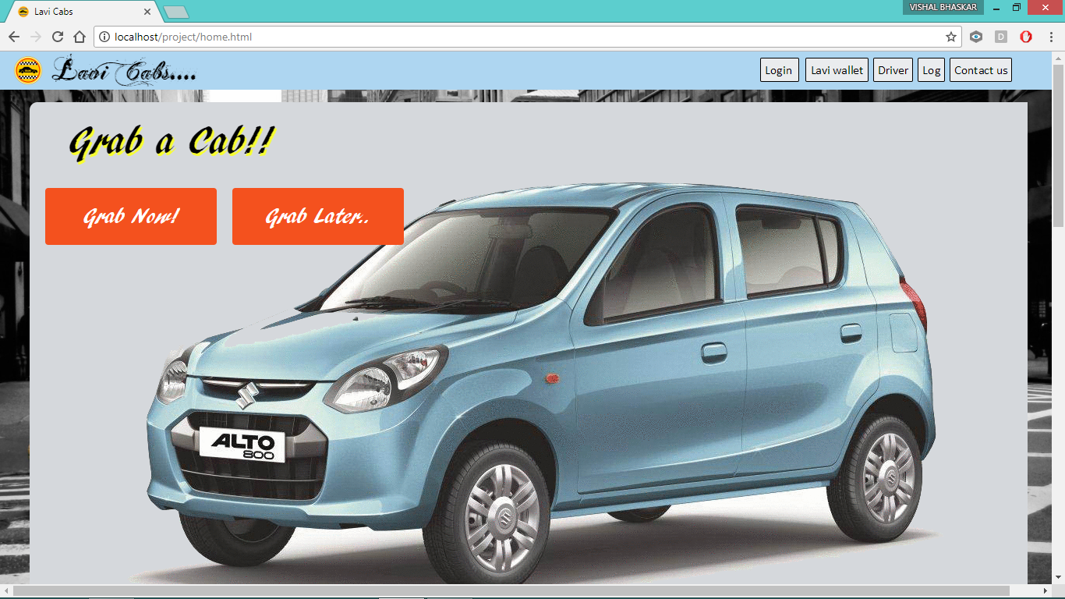

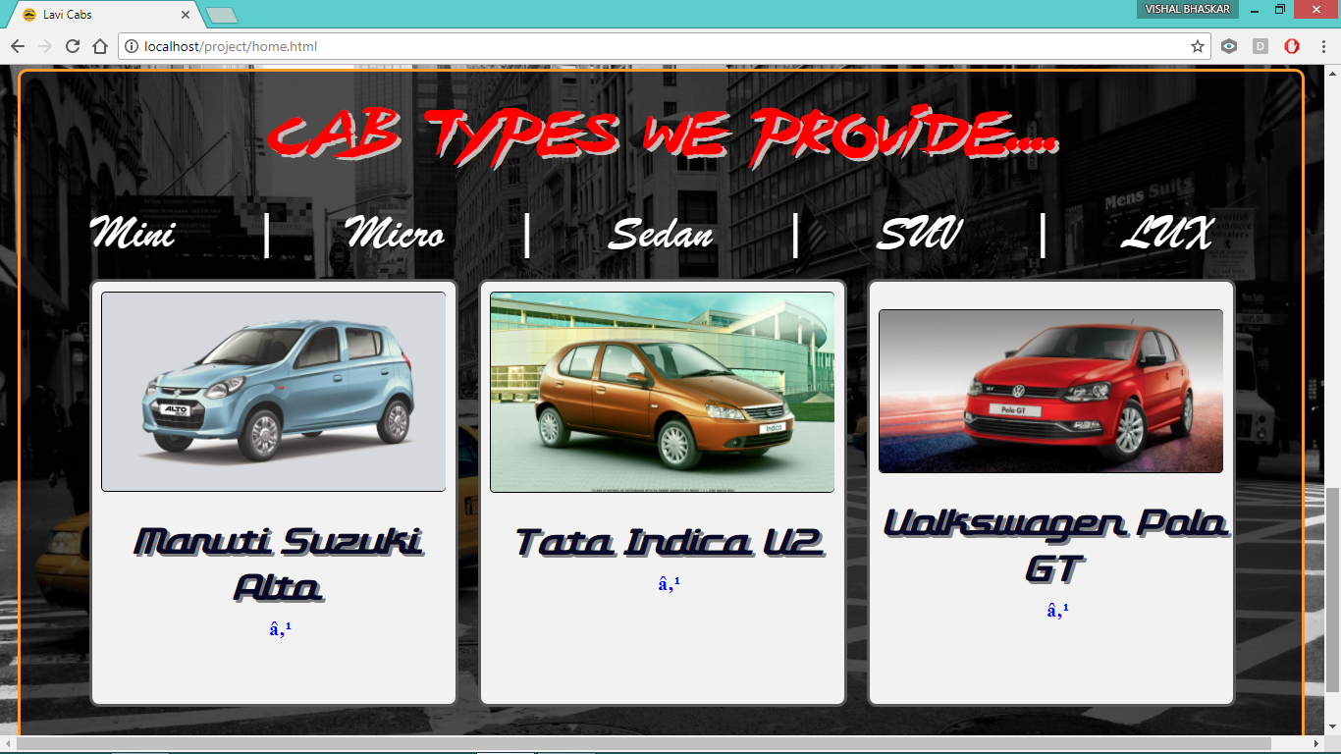

* 1. **Grab now**

The distance is calculated in real time using google API for java script.

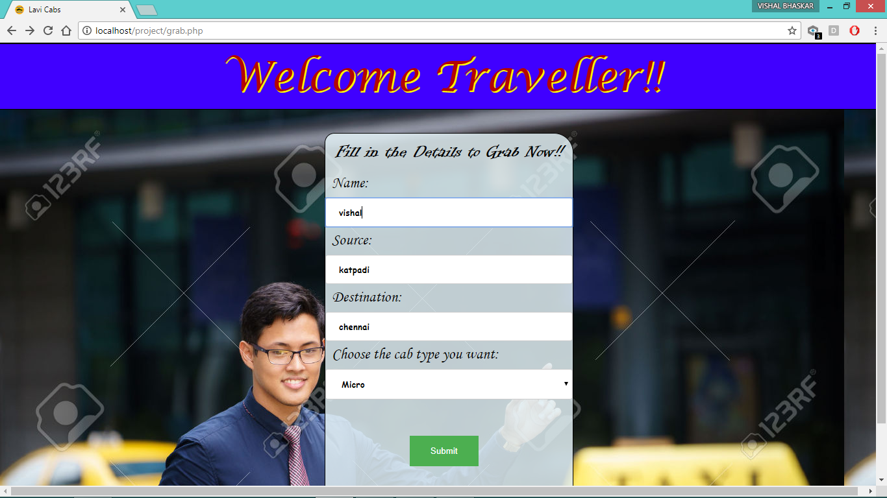

**After confirmation:**

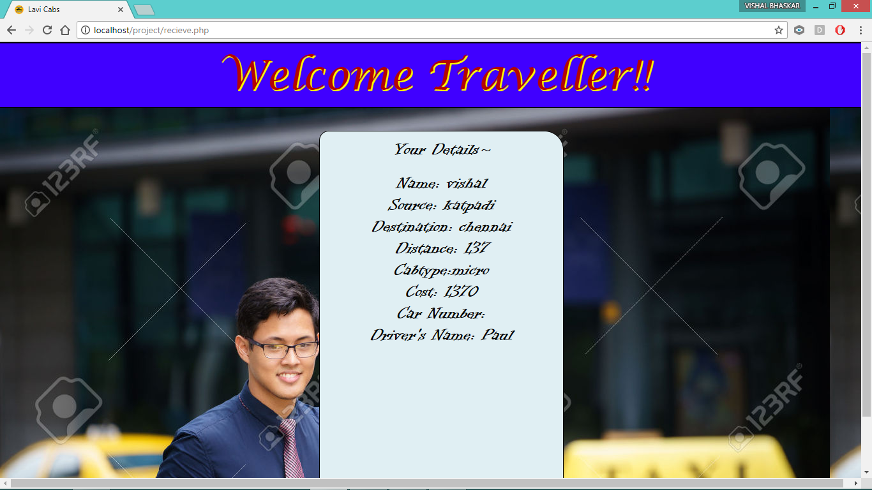

* 1. **Travel log**

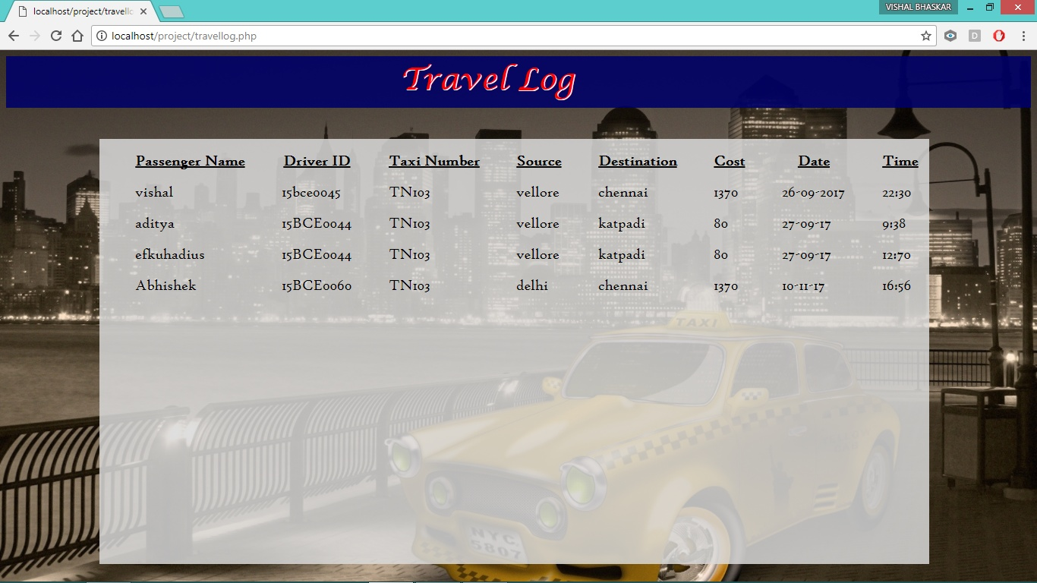

* 1. **Driver**

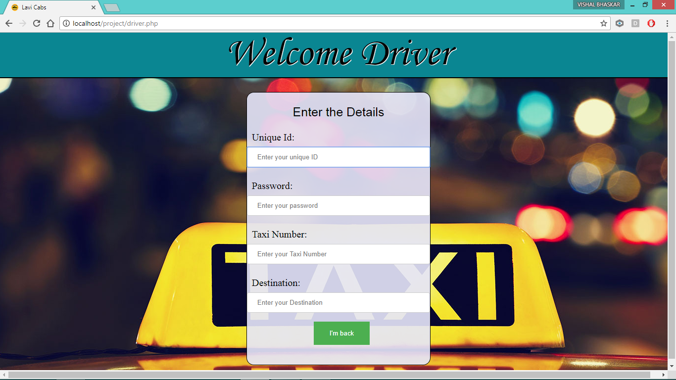

**3.5 Admin login**

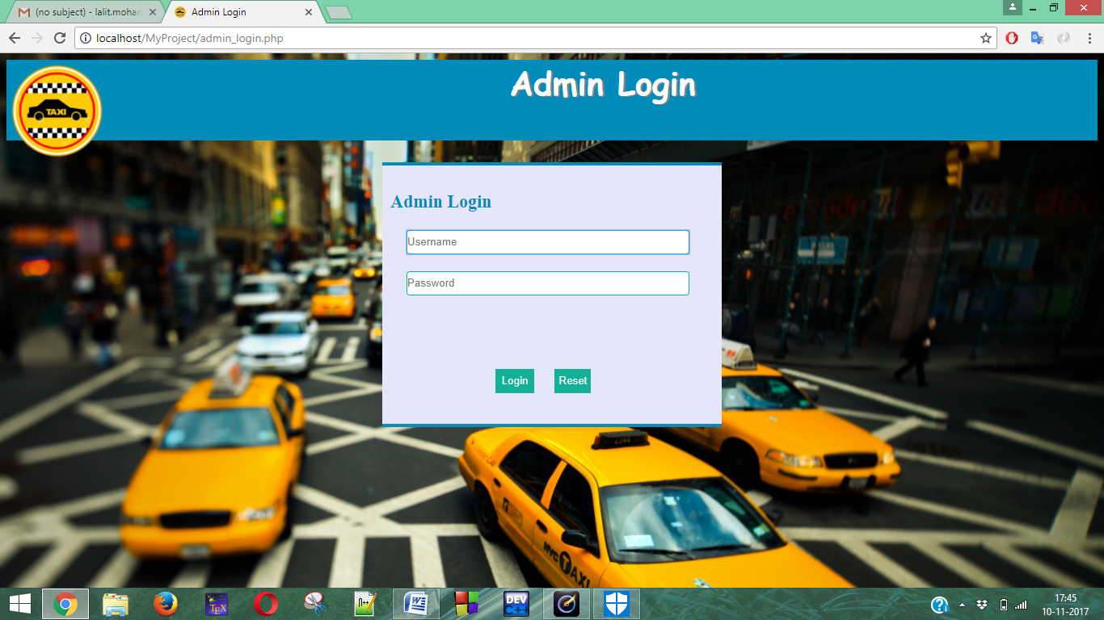

**3.6 Admin Page**

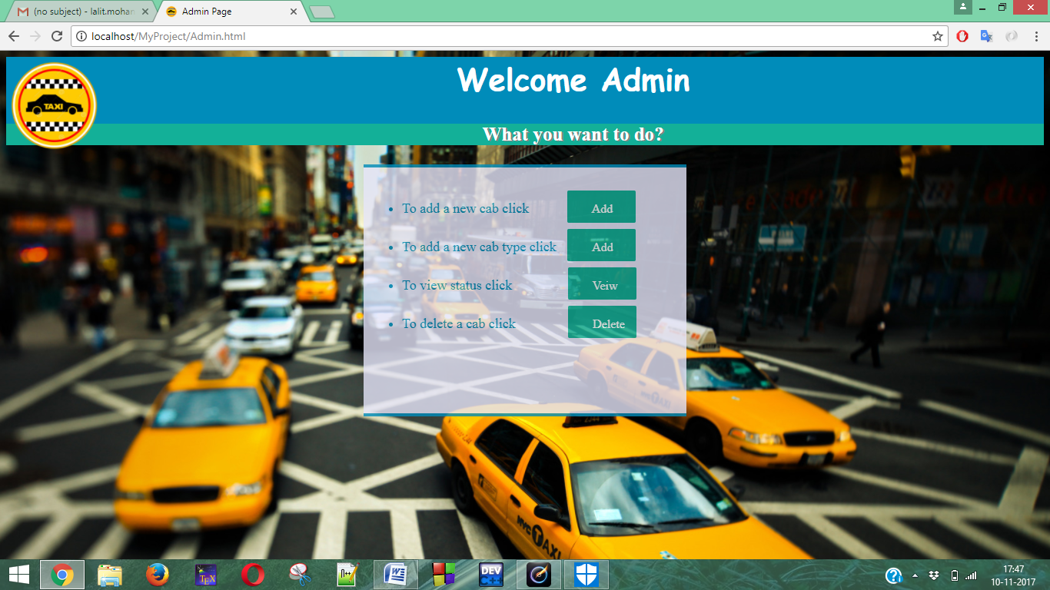

1. **The back end**

Here we are using MySQL to store the data. At first the availability of the cabs and driver is set to 1. Once a particular cab is booked, the status for that cab and the driver allocated to it changes to 0.

* 1. The cab table

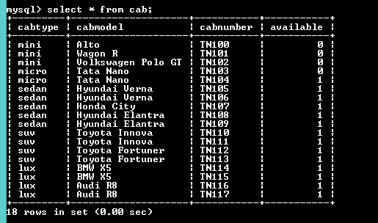

* 1. The driver table

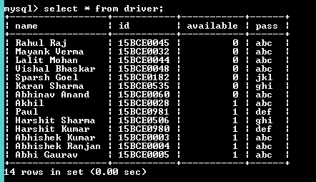

* 1. The travel log table

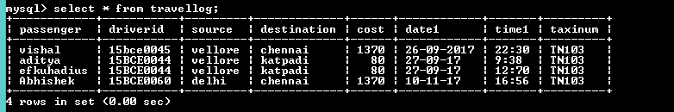

* 1. The cab cost table

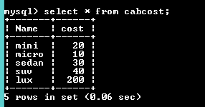

4.5 Admin

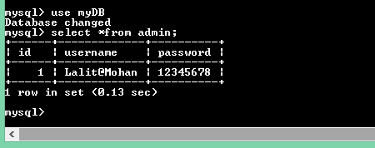

4.6 Cabs

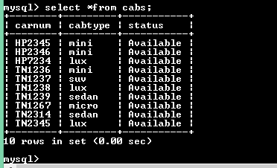

4.7 Cabtypes

